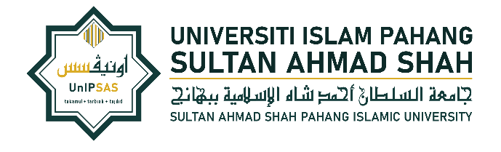 | PUSAT PENGURUSAN PENYELIDIKAN  Universiti Islam Pahang Sultan Ahmad Shah  KM-8 Jalan Gambang, 25150 Kuantan, Pahang.  Tel : 09 – 553 5555/ 5353/ 5351  Emel : rmc@unipsas.edu.my
BORANG PERAKUAN PENERIMAAN BAYARAN
PAYMENT RECEIPT CERTIFICATE FORM
RMC-PB-12
Tarikh diterima :
(Diisi oleh RMC)
A. | PERAKUAN PENERIMA | ACKNOWLEDGEMENT BY RECIPIENT’S
Saya mengesahkan telah menerima pembayaran seperti berikut:
I hereby confirm that I have received the payment as follows:
KATEGORI PERKHIDMATAN  Service Category  *Sila tanda ( √ )yang berkaitan | Please mark ( √ ) the relevant ones) |  |  | JUMLAH  BAYARAN (RM)  Total Payment (RM) | TEMPOH & TARIKH PERKHIDMATAN  Duration and Date of Service
Pembantu Penyelidik Siswazah (GRA) Graduate Research Assistance
Pembantu Penyelidik (RA)
Research Assistance
Pakar Bidang (SME)
Specialist in the Field
Pewasit Assessor
Pembaca Pruf Proofreader
Responden Respondent
Pembantu Lapangan Enumerator
Lain-lain (sila nyatakan):
Others (Please state):

Tandatangan Signature |  | :
Nama Name |  | :
No. Kad Pengenalan/ Pasport  NRIC/ Passport Number |  | :
Jawatan Position |  | :
Kaedah Pembayaran  Payment Method |  | :Tunai/ Perbankan Internet/ Cenderahati | Cash/ Online Banking/ Gift  *[Sila lampirkan slip/ resit pembayaran | Please attach payment slip/ receipt]
Tarikh Terima Date of Received |  | :
B. | DISAHKAN OLEH KETUA PENYELIDIK | VERIFIED BY PRINCIPAL INVESTIGATOR
Tandatangan Signature |  | :
Nama Name |  | :
No. Kad Pengenalan/ Pasport  NRIC/ Passport Number |  | :
Jawatan Position |  | :
Tarikh Date |  | :

